Here’s a concise Quick Troubleshooting flow suitable for Field Team as a guide
Quick Troubleshooting Flow – “No Connection to Unit” on Radio
- No Connection to Unit
⬇️
1. Check Power
- Is the unit powered ON?
- Check DC input, Fuse/MCB, and Power LED.
- No Power → Restore power → Check if the Module is restored.
⬇️
2. Check Physical Connections
- Verify RF/coaxial cable and connectors.
- Check Ethernet/communication cable, if applicable.
- Look for loose/damaged connectors or cable cuts.
- Connection issue → Rectify → Power cycle and ensure connectivity.
⬇️
3. Check Radio/Network Status
- Verify radio link/communication LEDs.
- Check signal/link status.
- Confirm correct frequency/channel/configuration.
- Abnormal → Correct configuration/link → Re-test
⬇️
4. Check Unit Reachability
- Verify IP/address or unit ID.
- Perform ping/connectivity test where applicable.
- Check whether the unit is reachable from the management system.
- Not reachable → Check transport/network path
⬇️
5. Check Alarms / PGOOD
- Review active alarms and event logs.
- Check PGOOD-related alarms as a unique fault cause.
- Verify whether the unit is repeatedly rebooting or losing power.
⬇️
6. Restart / Reset
- Perform controlled power restart.
- Re-establish connection and monitor stability.
⬇️
7. Still No Connection?
- Swap/replace suspected communication or RF hardware only after confirming the fault.
- Capture alarm, logs, measurements and replacement reasons.

On the BB module side:
1 | Fetch Snapshot
2 | Ensure alarm with Fault ID 10 is still active on WebEM
3 | Ensure the SFP(s) are securely plugged in
4 | Ensure the fiber cables are securely plugged into SFPs
5 | Clean SFP eyes and fiber cable ends
6 | Give radio power reset to see if the problem got solved
On the radio module side:
7 | Check DC voltage going to radio
8 | Check radio led status
9 | Connect LMI card to laptop with USB and Ethernet cables
10 | Connect LMI card to radio's LMI port
11 | Establish serial and ssh connections to radio
12 | Fetch radio logs via ssh
13 | Inspect optical fibers and connections visually
14 | Ensure the SFP(s) are securely plugged in
15 | Ensure the fiber cables are securely plugged into SFPs
16 | Disconnect fiber cables from SFPs
17 | Inspect SFP eyes and fiber cable ends with microscope, take photos
18 | Check the SFP type and ensure its correct
19 | Clean SFP eyes and fiber cable ends
20 | Insert SFPs back to radio

1. Check if the connector seal is properly mounted and firmly in place. Plug out the SFPs, clean up or change of SFP/Fiber if needed.
2. Check if the SFP is properly connected and/or mounted in the RF module. If the SFP connection and/or mounting isn't correct, readjust the connection and/or mounting.
3. Check if the LED indicates the faulty SFP (connected to the system module). Replace the SFP if it's faulty.
4. Check if the optical cable is properly connected and/or mounted in the SFP.
5. Clean the optical connectors at the RF module end. Reset/Power cycle the RF HW unit and check if this solves the problem.
6. After all these steps if issue persist, Replace the Radio.

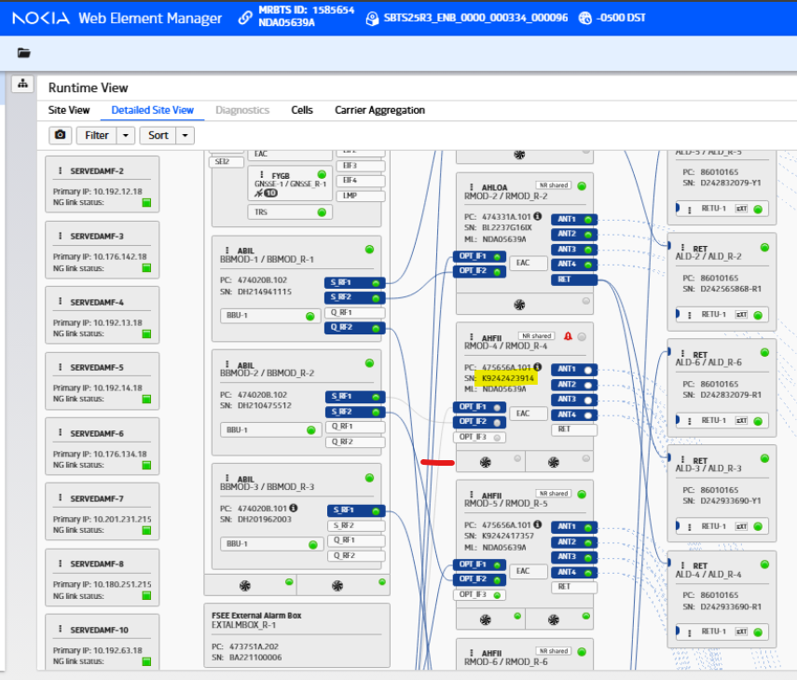
SFP Monitoring screenshot taken from WebEM , no readings available to view between the BBMOD_R-2(Left_Middle)/s_rf1/RMOD_R-4 serial_no=K9242423914

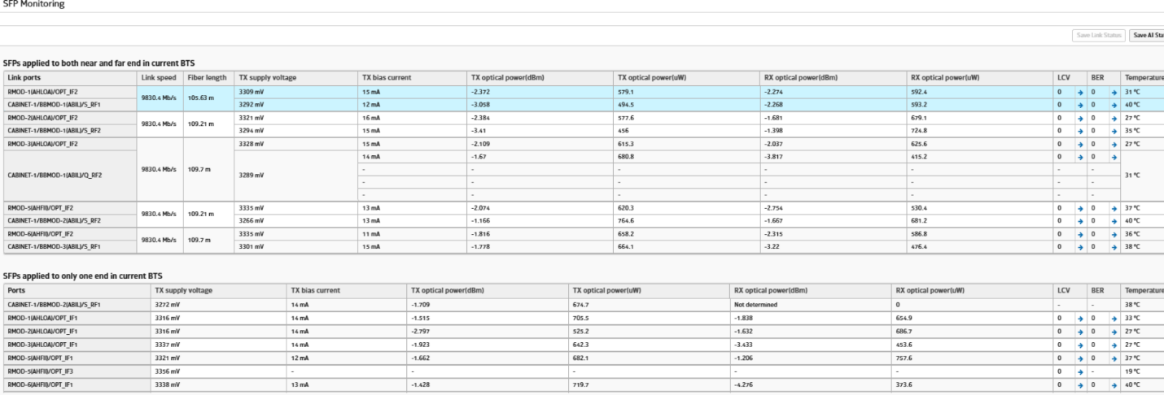

- Verify Physical Connections:
  - Ensure all network cables (Ethernet, fiber, etc.) connected to the unit are securely plugged in at both ends.
  - Check for any visible damage to the cables or connectors.
  - Clean the SFP’s and the ports (sometimes the dust/moisture also interferes the connections).
  - Replace the SFP’s between BBMOD and Radio.
  - Swap the fiber connections between the 2 sectors to see if the issue follows.
- Check Power Supply:
  - Confirm that the unit is powered on and receiving adequate power.
  - Look for power indicator lights on the unit.
  - Verify that the power source (e.g., power outlet, power distribution unit) is functional.
  - Look for any status LEDs on the unit that might indicate a fault.
- Restart the Unit/System:
  - As a last resort, if all other checks pass, try power cycling the unit. This can sometimes resolve transient communication issues.
  - Consider restarting any intermediate network devices (e.g., switches, routers) if they are suspected to be part of the communication path.

- Infra (Power Outages)/Environmental Issue (Cold Weather, Storm, Lightning strike etc.,)

To maintain reliable backup power, efficient energy management, and proactive maintenance at sites to prevent outages, especially during extreme weather or grid instability.
Also, operator make sure sites are installed with lightning rods (or lightning conductors), which attract strikes and safely guide the current to the ground, and surge protectors (or SPD), which protect electrical appliances from Voltage spikes have lightning protection system (grounding) to direct electricity into the ground.

  - Example from a site, 5TC3052A where the AEHC radio was replaced by TMO FOPS due to FID-10 however the actual issue was caused by other module not by the radio.

Actual module was Jumper up top and SFPs. They suggestion here is to replace strategically starting with smaller units like SFP/Fibers/Jumpers etc Instead of replacing BBMOD/RADIO at very first place.
Also, we observed during this drill down exercise there were multiple site visits which also could be avoided.
Below are screenshots of the site during the recovery process where it went through different HW replacements: -
Replacement date – 06th March ( Old serial- AH232100237 and New serial- AH223301527)
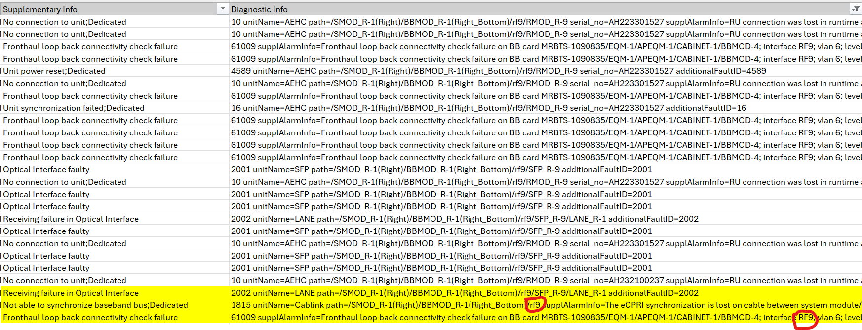

FID61009 - Fronthaul Loopback Fail on BBMOD-4 RF9(ABIO) to RMOD-9 IF-2(AEHC).
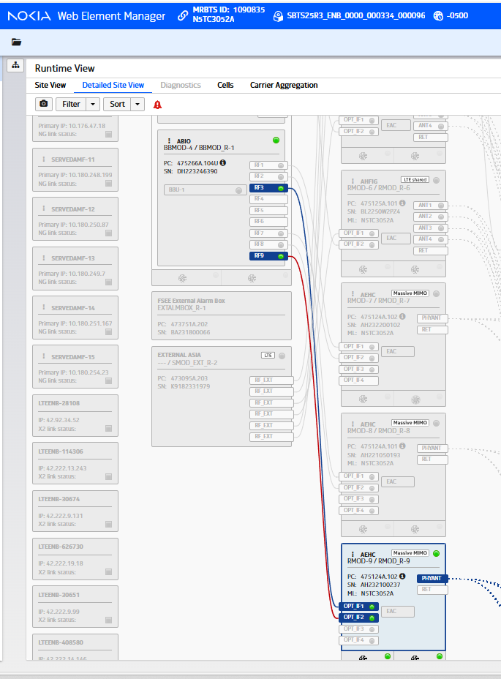
HARDWARE - ABIO-4 RF3 RECEIVING FAILURE IN OPTICAL INTERFACE / BTS CONFIGURATION ERROR (not enough HW for LCR) 1099 - 5TC3052A - BREAKFIX - HARDWARE - POSSIBLE ABIO BBMOD4 FAULTY ON RF3 PORT
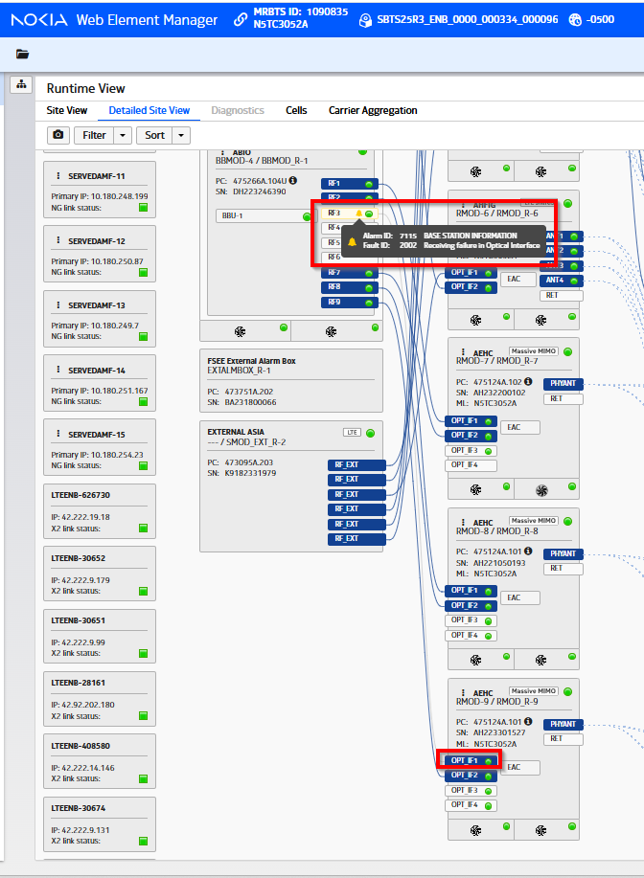
After hours of troubleshooting and replacing ABIO I moved Fiber from RF9 to RF3 and confirmed port RF3 is good. Issue is up the Fiber path to the tower top.
This confirms Port RF3 and the ABIO, AMIA, and ASILs.
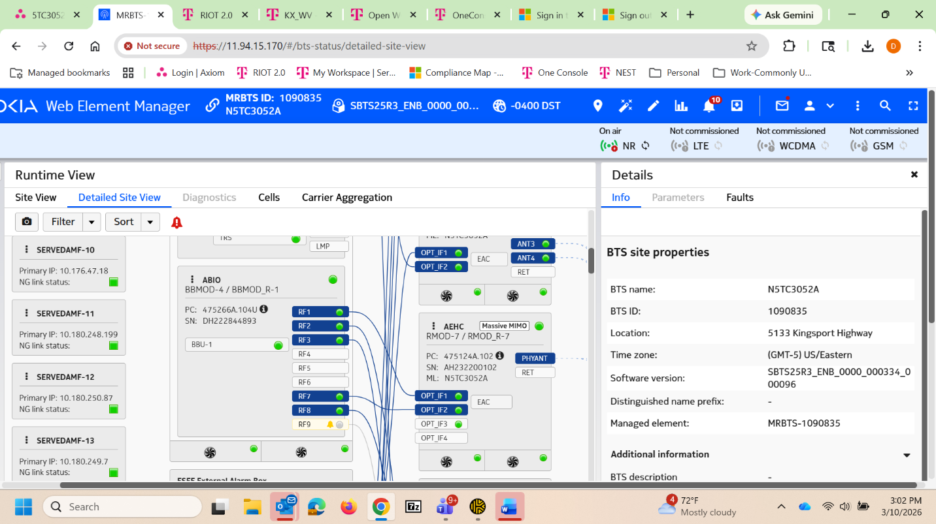

I put the original ABIO back in and moved RF9 Fiber to RF3 and RF3 on this original ABIO is working. Another confirmation the issue appears to be in the Fiber path from RF3 to IF1 of gamma AEHC.
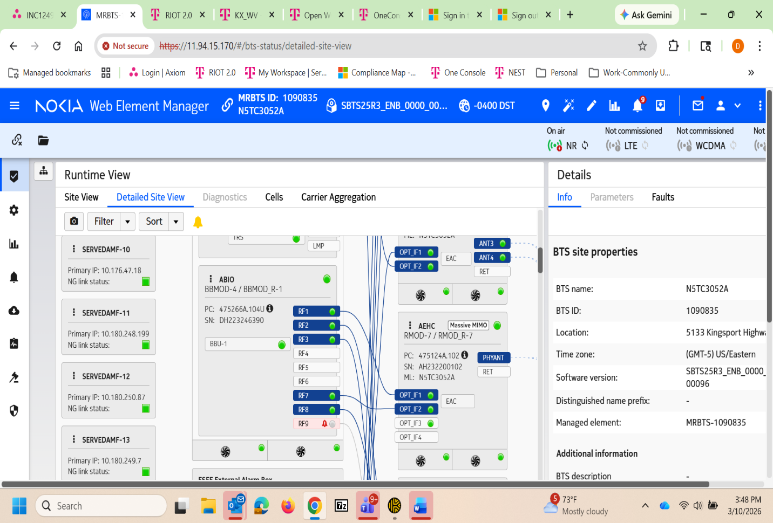
After previous topside investigation and extensive downstairs troubleshooting by FOPs, the issue appears to be in the fiber path from baseband card RF3 to IF1 of gamma AEHC. Need more topside investigation.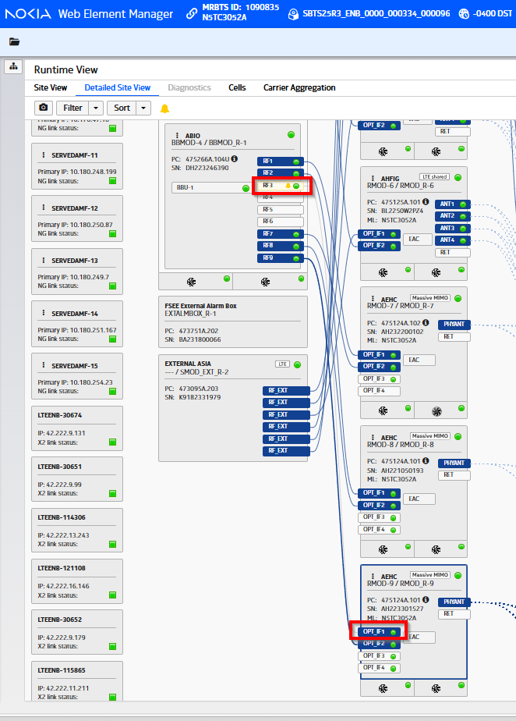

Resolution Notes: -
TC replaced jumper up top and replaced SFP at radio. Also corrected a few other
minor issues while onsite.

- Troubleshooting Fault ID 1907 TX out of order

START → Fault 1907 “TX Out of Order”
⬇️
1. Check Alarm Status
- Confirm Fault ID 1907 is active.
- Check whether the alarm is intermittent or persistent.
⬇️
2. Check Radio Power
- Verify unit/Radio power is stable.
- Check DC input, fuse/MCB and power LEDs.
- Look for repeated reboot/power fluctuation.
Power abnormal → Rectify power issue → Clear alarm → Re-test
⬇️
3. Check TX Path
- Inspect TX/RF cable and connectors.
- Check for loose, damaged or improperly seated connectors.
- Verify RF path/feeder condition.
- Check for abnormal VSWR/reflected power, if available.
TX path abnormal → Rectify → Re-test
⬇️
4. Check Radio Configuration
- Verify TX frequency/channel configuration.
- Check TX enable/mute status.
- Confirm configuration matches the connected unit/network.
- Check recent configuration changes.
⬇️
5. Check TX Hardware Status
- Review radio/module diagnostics.
- Check PA/TX module alarms and temperature status.
- Check whether TX output is actually being generated.
TX output absent/abnormal → Suspect TX/PA hardware
⬇️
6. Check Related Alarms
Look for accompanying alarms such as:
- PA/Power Amplifier fault
- High VSWR
- Over-temperature
- PGOOD/power-related alarm
- Module communication failure
- PLL/frequency-related fault
⬇️
7. Reset & Re-test
- Perform controlled reset/restart as per approved procedure.
- Clear the alarm.
- Verify TX operation and monitor for recurrence.
⬇️
If Fault 1907 Persists
Confirm external RF path → Confirm configuration → Check TX/PA module → Replace HW only after fault confirmation → Escalate with logs/alarms and test results.
Recommended fault classification:
1907 TX Out of Order → TX/Radio Transmission Path Fault
If investigation confirms a PA/TX hardware failure, classify the unique cause as TX/PA Hardware Fault rather than simply “TX Out of Order.”
- Nokia Fault 1815 – (Not able to synchronize baseband bus)
eNodeB (LTE) or gNodeB (NR) cannot establish Synchronization between the System Module (ASIL/ASIM/BBMOD) and the RF Module / Radio Module over the Baseband Bus (BB Bus / RP3 interface). This usually causes cells or the whole BTS to go out of service (OoS).

Fault ID: 1815
- 1815: EFaultId_BbBus_SyncFailedAl
Typical Alarms reported:
- 7650 Base Station Faulty
- 7651 Base Station Operation Degraded
- 7653 Cell Faulty
- 7654 Cell Operation Degraded

Main Causes of Fault 1815
1. BB Bus / Optical Cable Problem
Most common reason:
- Loose or damaged CPRI/RP3/OBSAI cable
- Wrong cable connection
- Dirty optical connector
- Fiber bend or attenuation issue
2. RF Module Failure
The RF module may:
- Hang during startup
- Fail synchronization
- Have internal FPGA/DSP failure
- Overheat or reset repeatedly
3. System Module Failure
Possible issues:
- Faulty FSP/ASIL/ASIM/BBMOD
- Corrupted synchronization configuration
- HW communication failure
4. Software or Configuration Mismatch
- Wrong BTS configuration
- Incorrect RP3 link speed
- Incompatible SW versions
- Incomplete commissioning
5. Clock / Sync Issue
If reference clock is unstable:
- BB bus synchronization may fail
- Related alarms like 1816 may appear

Troubleshooting Procedure (Recommended by Nokia Practice)
Step 1 — Check Other Active Alarms
First verify if any of these faults are in the Active Alarm or History:
- 1811
- 1904
- 1905
- 1906
- No connection to unit alarm (10)
These often indicate the real root cause.

Step 2 — Check Physical Connectivity
Inspect carefully:
- Fiber/copper BB bus cable
- CPRI cable seating
- Optical SFPs
- RF module ports
- Connector cleanliness
Actions:
- Remove and reconnect
- Swap fiber
- Clean optical ports
- Verify TX/RX not crossed

Step 3 — Verify Module LEDs
Check:
- RF module LEDs
- System module LEDs
Typical indication:
- Red/blinking red(HW or sync failure
- No LED (power or hardware issue)

Step 4 — Reset the Faulty Unit
Recommended recovery:
- Block RF module
- Unblock RF module
- If not recovered:
  - Block/unblock System Module
- Reboot BTS if necessary

Step 5 — Check BB Bus Configuration
Verify:
- RP3 link speed
- Radio type mapping
- Sector-to-radio mapping
- Daisy chain/routing direction
Wrong routing direction can trigger BB synchronization alarms.

Step 6 — Swap Hardware
If fault persists:
- Replace BB bus cable
- Replace SFPs at both the ends (BBMOD & RMOD)
- Replace RF module
- Replace System Module

Field Experience Tips
Common practical observations from field engineers:
- 70% cases (Bad Fiber/CPRI connection
- Frequent after power fluctuation
- Common after incorrect commissioning
- Sometimes caused by incompatible radio software
- Water ingress in outdoor RF modules can trigger 1815 intermittently.

Quick Troubleshooting Flow

Check for all service impacting Alarms (Active and Historical as well – 15 Days).
Check/Inspect Fiber/BB cable
Check RF module LEDs
Block/Unblock RF module.
Power cycle the corresponding BBMOD/RMOD
Restart BTS
Verify RP3/CPRI configuration
Swap Cable/SFPs
Replace RF module
Replace System module

Important to note these Related Faults like FID1815:
Fault ID | Meaning
1811 | BB Bus configuration rejected
1904 | RF BB Bus synchronization error
1905 | RF BB Bus configuration error
1906 | RF BB Bus transmission error
3020 | Baseband Bus failure
3080 | BTS reference clock missing

- Troubleshooting VSWR and RTWP Issues

VSWR and RTWP are among the most common in LTE/5G RF issues affecting uplink/downlink quality, call drops, low throughput, and coverage degradation.

1. VSWR Issue Troubleshooting
What is VSWR?
VSWR (Voltage Standing Wave Ratio) indicates impedance mismatch between:
- RRU/RRH
- Jumper
- Feeder cable
- Antenna
High VSWR means reflected power is returning to the Radio.
Normal:
- ≤ 1.5 : Good
- 1.5–2.0 : Acceptable
- 2.0 : Problematic

Symptoms of High VSWR
- Cell degraded alarm
- Low DL coverage
- High reflected power
- RRU PA shutdown
- Call drops
- Low throughput
- Sector outage in severe cases
Typical alarms:
- VSWR threshold crossed
- TX path fault
- Antenna line fault
- High reflected power alarm

Main Causes of VSWR
Cause | Description
Loose jumper | Connector not tightened
Damaged jumper | Water ingress or bent cable
Faulty feeder | Internal cable damage
Bad antenna | Internal antenna failure
Water ingress | Moisture in connector
Corroded connector | Oxidation increases mismatch
Wrong connector type | DIN/N-type mismatch
Lightning damage | Burns RF path
Poor installation | Improper connector crimping

1. VSWR Troubleshooting Procedure
Step 1 — Check Alarms
Verify:
- Which sector?
- Which TX/RX branch?
- Intermittent or permanent?
Check:
- VSWR value
- Reflected power
- TX power reduction

Step 2 — Physical Inspection
Inspect:
- Jumper cables
- Feeder connectors
- Antenna ports
- Weatherproofing tape
- Water leakage

Look for:
- Rust
- Blackened connectors
- Moisture
- Loose DIN connectors

Step 3 — Tighten Connectors
Use proper torque wrench:
- Over-tightening also causes problems.
Common field issue:
- Connector finger-tight only.

Step 4 — Swap Jumpers
Swap:
- Jumper with healthy sector
If fault moves:
→ Jumper faulty.

Step 5 — Measure with Site Master / Anritsu
Best practice:
- Disconnect antenna line
- Measure Return Loss / VSWR
Typical findings:
- Distance-to-fault (DTF)
- Connector mismatch
- Feeder damage point

Step 6 — Check Antenna
Possible issues:
- Internal antenna damage
- Water ingress
- Burned diplexer
- PIM issue
Swap antenna port if possible.

Step 7 — Check RRU/RRH Port
Sometimes issue is:
- Damaged RF port
- Burned circulator
- Internal PA failure
Swap RF port/branch.

VSWR Quick Isolation Logic
Alarm appears
↓
Check connector tightness
↓
Swap jumper
↓
Measure feeder with Site Master
↓
Replace jumper/connector
↓
Check antenna
↓
Check RRU port

2. RTWP Issue Troubleshooting
What is RTWP?
RTWP (Received Total Wideband Power) measures total uplink noise/interference at the receiver.
Used mainly in:
- WCDMA
- LTE uplink analysis
Normal RTWP:
- Around −105 dBm to −95 dBm (depends on load)
Problem indication:
- One branch significantly higher than others

Symptoms of RTWP Issue
- UL interference
- Poor upload throughput
- Call setup failure
- High BLER
- Accessibility degradation
- UL packet loss
Typical KPI impact:
- CSSR degradation
- Drop increase
- UL throughput low

Main Causes of RTWP Imbalance
Cause | Description
External interference | Noise source nearby
Faulty TMA | Generates noise
Water ingress | Creates passive intermodulation
Bad jumper | UL noise increase
Faulty antenna | Internal imbalance
PIM issue | Passive Intermodulation
Cross feeder issue | Improper cabling
RRU receiver fault | Defective RX chain

RTWP Troubleshooting Procedure
Step 1 — Compare RTWP Between Branches
Healthy:
Branch A = -101 dBm
Branch B = -102 dBm
Problem:
Branch A = -88 dBm
Branch B = -102 dBm
Difference > 3 dB usually indicates issue.

Step 2 — Check Time Pattern
Questions:
- Constant issue?
- Busy hour only?
- Random spikes?
If busy-hour only:
→ External interference likely.

Step 3 — Swap RX Paths
Swap:
- Jumper
- RX branch
- Antenna port
If issue moves:
→ External RF path issue.
If stays:
→ RRU issue.

Step 4 — Check PIM Sources
Common causes:
- Loose connector
- Rusted feeder
- Metal contact near antenna
- Poor grounding
PIM creates uplink noise.

Step 5 — Spectrum Analysis
Use:
- Spectrum analyzer
- Interference hunting tools
Look for:
- Repeater interference
- Illegal booster
- External transmitter

Step 6 — Disable External Devices
Check:
- TMA
- RET
- Combiner
- Diplexer
Bypass temporarily.

Step 7 — Check Antenna Alignment
Wrong tilt or damaged antenna can:
- Increase interference pickup
- Cause RTWP imbalance

RTWP Isolation Logic
High RTWP detected
↓
Compare branches
↓
Swap RX paths
↓
Check jumper/feeder
↓
Check PIM sources
↓
Spectrum analysis
↓
Replace antenna/TMA
↓
Replace RRU

Difference Between VSWR and RTWP
Parameter | VSWR | RTWP
Direction | Downlink TX path | Uplink RX path
Main issue | Reflection | Interference/noise
Affects | TX efficiency | UL sensitivity
Common tool | Site Master | Spectrum Analyzer
Main symptom | Reflected power | High UL noise

Practical Field Tips
VSWR
- Most common cause = loose jumper
- Water ingress is extremely common in coastal areas
- Always inspect weatherproofing
RTWP
- PIM is often hidden root cause
- Compare neighboring sectors
- Interference may come from external operators

Important KPI Thresholds
Parameter | Healthy
VSWR | < 1.5
Return Loss | > 14 dB
RTWP imbalance | < 3 dB
UL Noise Floor | Around −100 dBm

- One of the examples of these issues we have witnessed recently where HW (Radio) is not replaced.
BTS Name: M9BH8040A
MRBTS ID: 1113869
HW Module/SN: AHLOB/ AH252321874
Alarms per NAF History: VSWR (1837) / Transmission path failure (4003) / Antenna line switched off due to high VSWR (1957).
TMO INC’s (Tickets): INC125072668 (Closed) / INC126848908 (Open)
Radio Replacement status: Radio not replaced.
Issue: VSWR
Resolution: Tower crew to troubleshoot Alpha AHLOB SN:AH252321874 VSWR upper threshold exceeded -ANT2. FOPS incident TC replaced the Jumper.
Replaced jumper. Troubleshooting the Alpha AHLOB (S# AH252321874) for a Major VSWR alarm. Tested the RF Jumpers and cleaned the connections.
Replaced the RF Jumper on the Alpha AHLOB. Issue resolved. Logged out with Semester Grimes. Site complete.
- NokiaFault-1927_RF_Power_decreased indicates a detected reduction in the Radio Frequency (RF) output power from a Nokia network element, which can impact network performance and coverage.
Understanding NokiaFault-1927_RF_Power_decreased
This fault signifies that the RF power output from a base station or radio unit has fallen below its expected or configured level. This can lead to reduced cell coverage, lower signal quality for users, and decreased data throughput.
Common Causes for Decreased RF Power in Nokia Equipment
Decreased RF power can stem from various issues, including:
- Hardware Malfunctions:
  - Faulty Radio Unit (RRH/RFM): The radio unit itself might be defective.
  - Antenna Issues: Damaged or misaligned antennas, or issues with the antenna's internal components.
  - Feeder Cable Problems: Damaged, corroded, or improperly connected RF feeder cables (coaxial cables) between the radio unit and the antenna.
  - Connector Issues: Loose, corroded, or damaged RF connectors.
  - Power Supply Problems: Insufficient or unstable power supply to the radio unit.
- Configuration Errors:
  - Incorrect Power Settings: RF power levels might be misconfigured in the network management system or directly on the equipment.
  - Software Glitches: Bugs or errors in the radio unit's software.
- Environmental Factors:
  - Extreme Temperatures: Operating outside specified temperature ranges can affect RF component performance.
  - Moisture Ingress: Water damage to cables, connectors, or radio units.
- External Interference: While less common as a direct cause of decreased output power, severe interference can sometimes be misinterpreted or contribute to system instability that affects power output.
Troubleshooting Steps for NokiaFault-1927_RF_Power_decreased
To diagnose and resolve this fault, follow these general troubleshooting steps:
- Check Alarms and Logs:
  - Verify if other related alarms are present (e.g., VSWR alarms, hardware alarms, power supply alarms).
  - Review system logs for any events preceding the fault.
- Physical Inspection:
  - Cables and Connectors: Visually inspect all RF feeder cables and connectors for damage, corrosion, or loose connections. Ensure proper grounding.
  - Antenna: Check the antenna for physical damage or misalignment.
  - Radio Unit: Inspect the radio unit for any visible damage, proper seating, and ensure all cables are securely connected.
- Verify Power Supply:
  - Confirm that the radio unit is receiving stable and correct power voltage.
- Configuration Review:
  - Access the network management system (e.g., NetAct) or the local management interface of the radio unit.
  - Verify that the RF power settings are correctly configured according to the network plan.
  - Check for any recent configuration changes that might have triggered the issue.
- Perform VSWR Measurement:
  - If possible, perform a Voltage Standing Wave Ratio (VSWR) measurement to check the impedance match of the antenna system. High VSWR indicates a problem with the antenna, feeder cable, or connectors.
- Software Check:
  - Ensure the radio unit is running the approved software version. Consider a software upgrade or downgrade if recent changes correlate with the fault.
- Component Swap (Last Resort):
  - If all other steps fail, consider swapping the suspected faulty component (e.g., radio unit, feeder cable, antenna) with a known good one to isolate the problem.

Troubleshooting environmental external alarms focuses on the specific sensors and conditions they monitor. Here's a systematic approach:
Troubleshooting Environmental External Alarms
- Identify the Specific Environmental Alarm:
  - Determine the exact type of environmental alarm (e.g., high temperature, low temperature, high humidity, water leak, smoke/fire, air quality, power failure).
  - Note the alarm's exact message, threshold, and the sensor ID or location from your monitoring system.
- Verify Environmental Conditions:
  - Direct Measurement: Use a calibrated, independent device (e.g., thermometer, hygrometer, water detection strip) to physically verify the environmental condition at the sensor's location.
    - Example: If a high-temperature alarm triggers, check the actual temperature with a handheld thermometer.
  - Visual Inspection: Look for obvious issues in the environment:
    - Temperature: Blocked air vents, malfunctioning HVAC, open doors, heat-generating equipment.
    - Humidity: Leaks, condensation, humidifier/dehumidifier issues.
    - Water Leak: Visible water, drips, condensation, burst pipes.
    - Smoke/Fire: Visible smoke, burning smell, heat.
- Inspect the Sensor:
  - Physical Condition: Check the sensor for damage, dirt, dust, or obstructions that might affect its readings. Ensure it's securely mounted and positioned correctly.
  - Placement: Verify the sensor is in an appropriate location to accurately monitor the desired condition (e.g., not directly in front of an air vent, away from direct sunlight).
  - Connectivity: Ensure all cables connecting the sensor to the alarm panel or monitoring unit are secure, undamaged, and properly terminated.
- Check Sensor Calibration and Thresholds:
  - Calibration: If the sensor is field-calibratable, check its last calibration date and consider recalibration if readings are consistently inaccurate compared to your independent measurements.
  - Alarm Thresholds: Review the configured alarm thresholds in the monitoring system. Ensure they are set appropriately for the environment and that the current (verified) conditions are not legitimately exceeding them.
- Power and Communication:
  - Sensor Power: Confirm the sensor is receiving power (if applicable). Check indicator lights on the sensor or its associated module.
  - Communication Link: Verify the communication path between the sensor and the monitoring system (e.g., wired connection, wireless signal strength, network connectivity).
- Review Logs and History:
  - Check the monitoring system's event logs for a history of the alarm. Look for patterns, intermittent triggers, or other related alarms that might provide context.
- Test the Sensor (if safe and feasible):
  - Temperature: Gently apply a heat source (e.g., hairdryer on low, but not directly on the sensor) or a cold source (e.g., ice pack wrapped in cloth) to see if the sensor responds and triggers the alarm at the set threshold.
  - Water Leak: Apply a small amount of water to the water leak sensor.
  - Smoke: Use approved test smoke spray for smoke detectors.
- Reset and Monitor:
  - After addressing any identified issues, clear the alarm (if possible) and monitor the system to confirm the alarm does not reoccur.

